**Verification Plan for MHMessenger Application**

Apache & Tomcat upgrade

* Check - application is up & running.

As soon as we received the mail from the respective team, asking us to validate the application after the patching activity is over, hit the production url on the browser.

**https://mhmessenger.malaysiaairlines.com**

Login page will be visible for this app.

Now you can login and move forward with the verification of application.

Simultaneously capture the artifacts for proof.

* Artifacts:

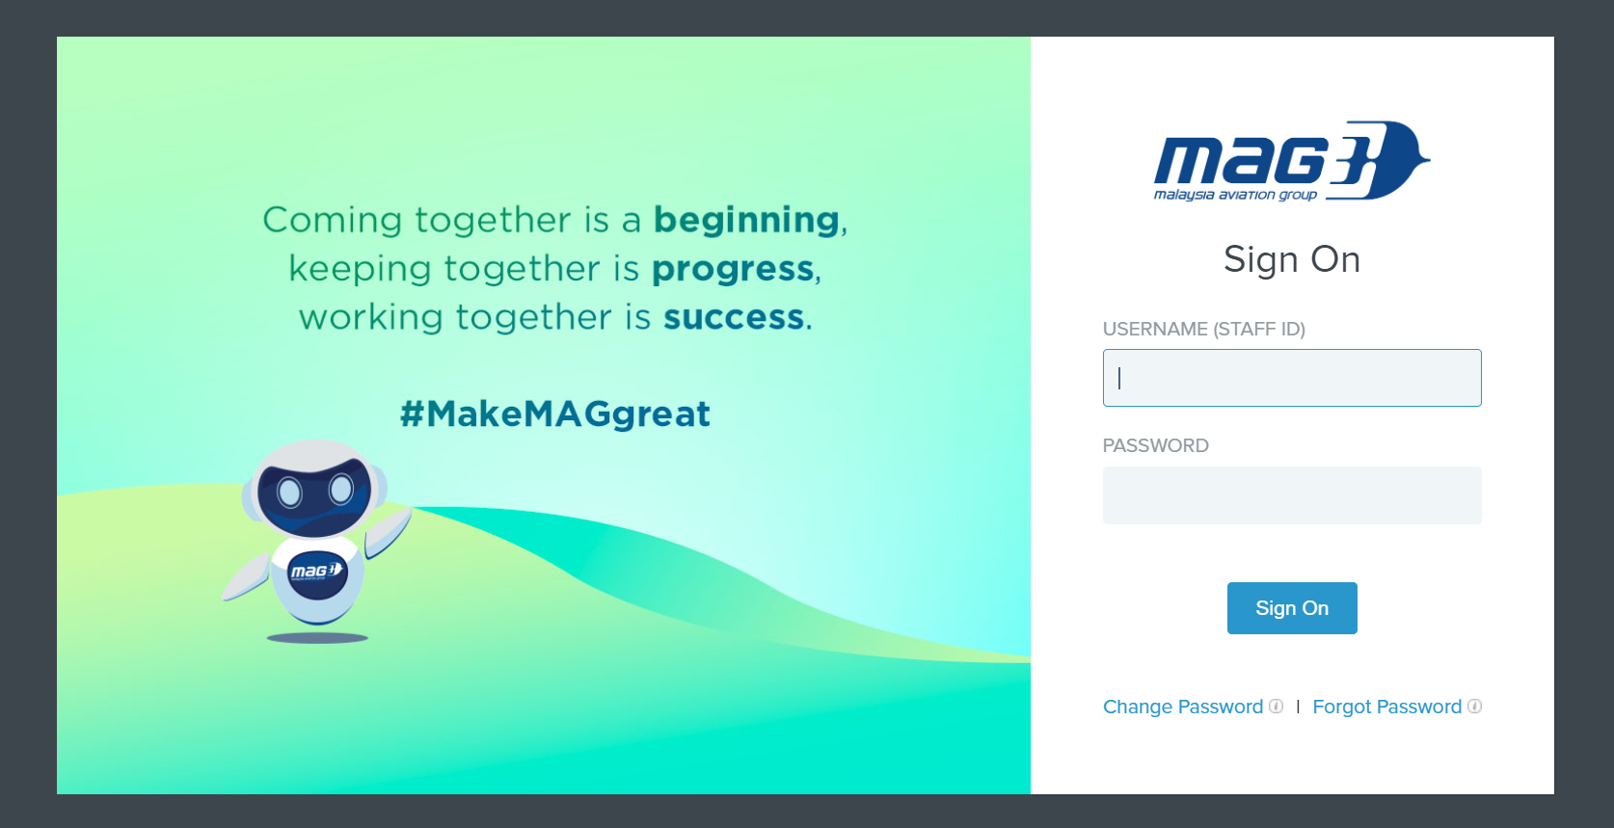

* Application Login is working fine.

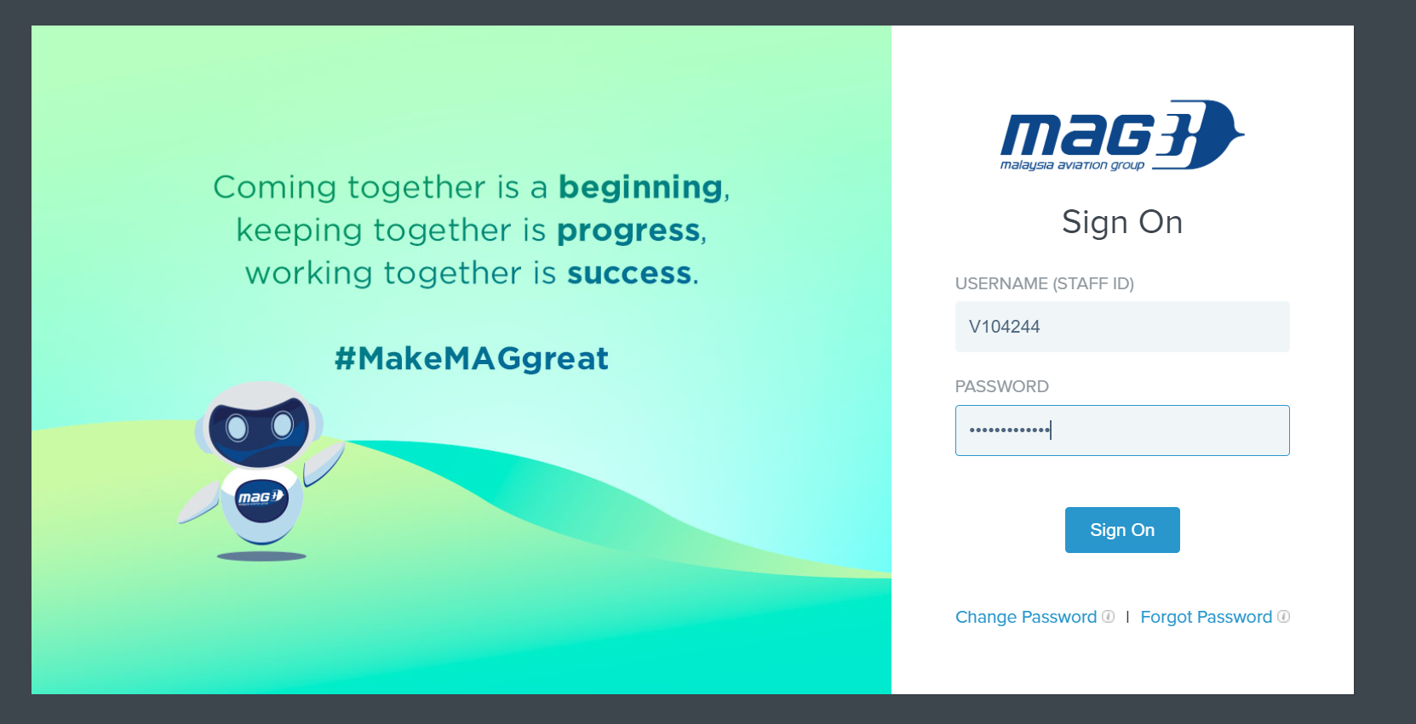

* Released functionality./Basic functionality.
* Home page - after login is successful

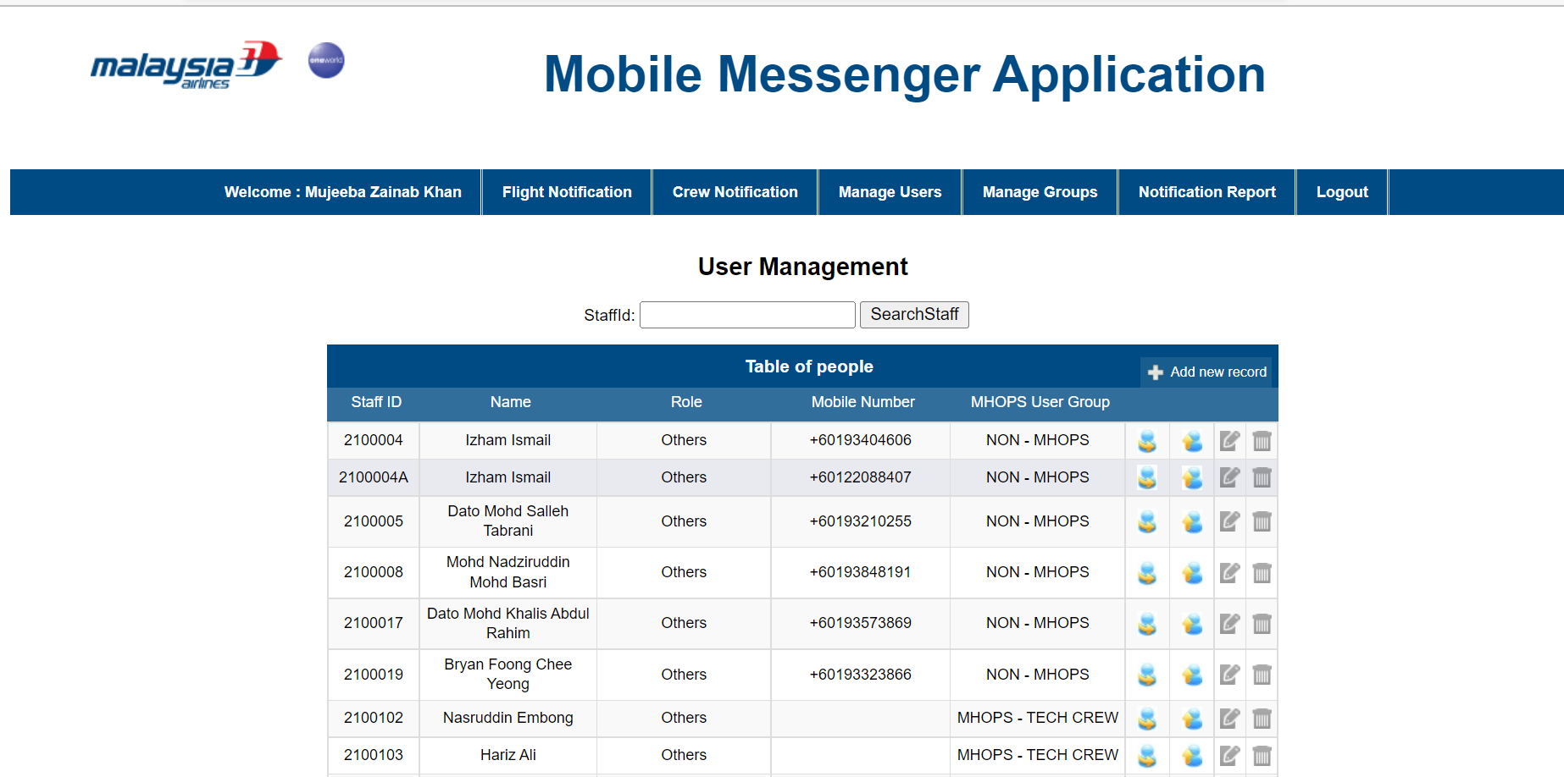

* Flight Notification Page

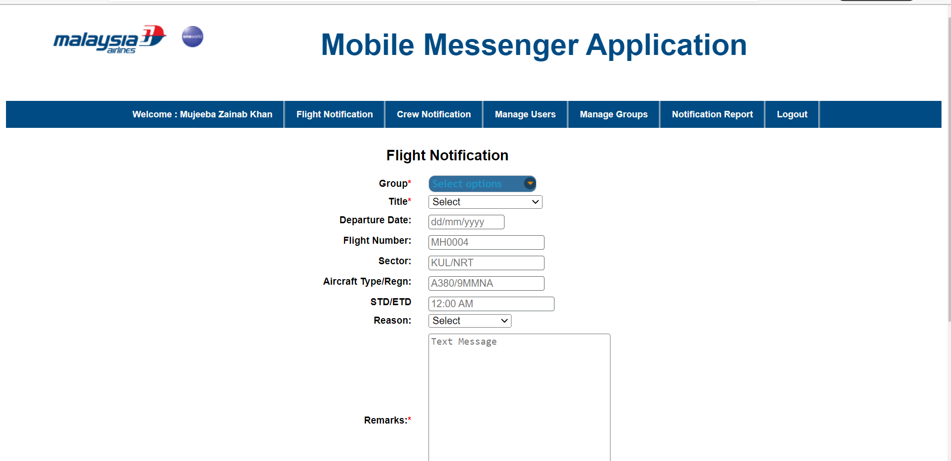

* Crew Notification page

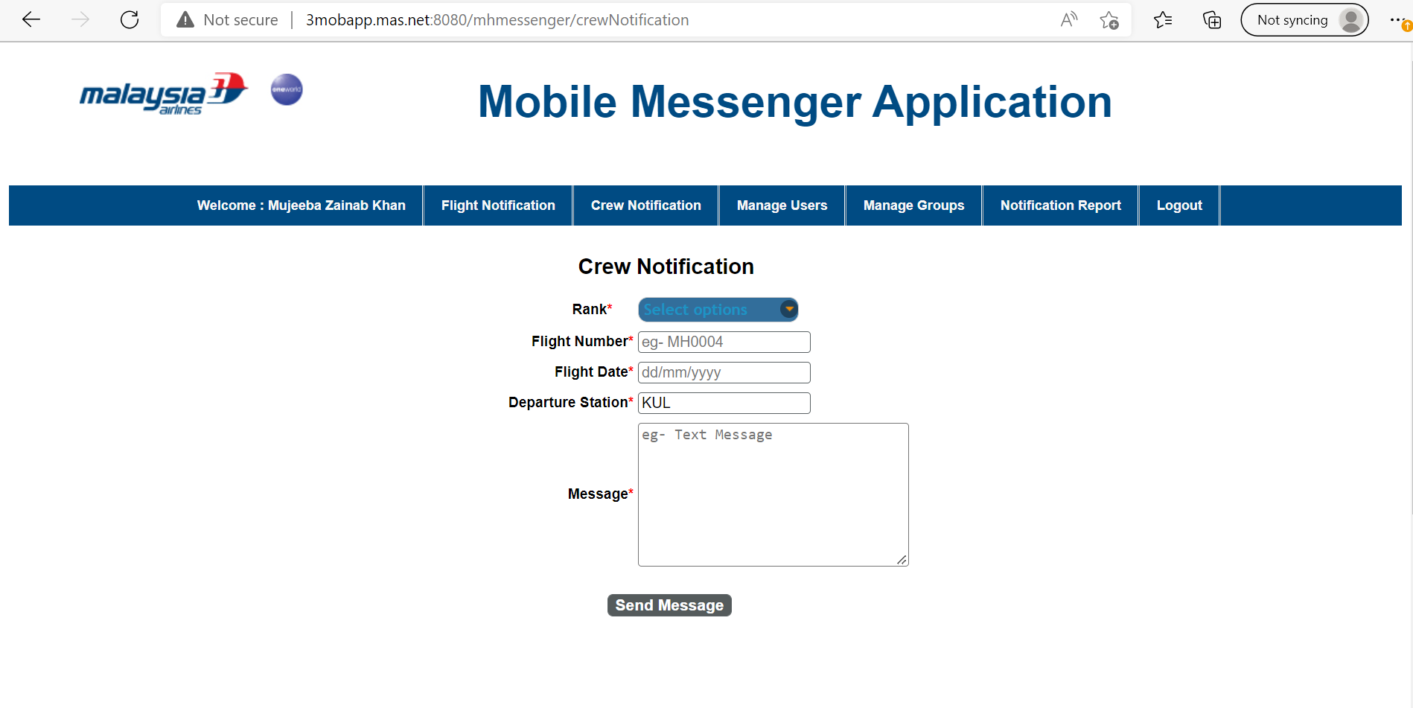

* Search by staff ID

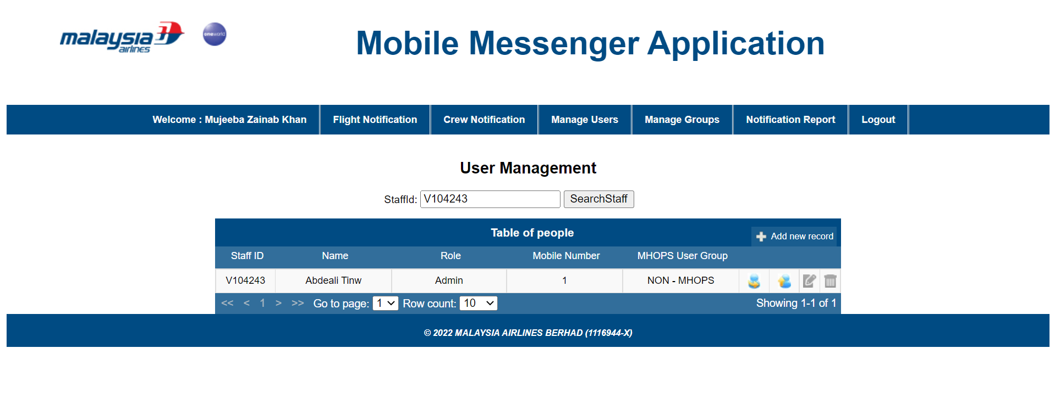

* Verify the log - Check for any unexpected error.

As you will be having the server access for this application – Check the logs with this

**ip-** 10.221.4.24

**logpath -** /tomcat/apache-tomcat/logs/MHMessenger_Log.log

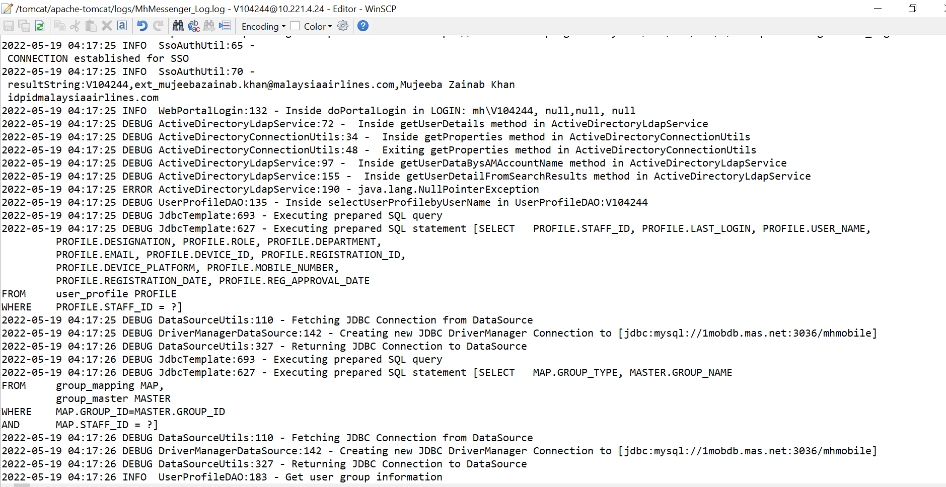

As we have validated the application and its working fine, now revert back with the same acknowledgement to that particular mail.